SAMPLE (One line space for the first page)
Instructions for the Preparation and Format of a Manuscript (Type A)
Subtitle with hyphens; If Necessary
13pt Roman for Title (centered)
by
11pt Roman for author(s)
(centered)
9pt Roman for “by”
Taro NIPPON* and Hanako CIVIL**
9pt Roman for abstract
(One line space)
A manuscript should be prepared with a laser printer or equivalent output with higher quality than a 24 dot-printer. You must submit A4 sheets with a top margin of 25 mm, left and right margins of 21 mm, and a bottom margin of 22 mm. The title and the name(s) of the author(s) should be printed on the first page, followed by the abstract of 200-300 words, giving a brief account of the most relevant aspects of the paper. Each paper must include five to ten keywords in order to indicate the main topics discussed in the paper and to provide basic terms for indexing. Main text will start with a line spacing above. All figures and tables are positioned within text.
9pt Italics for Key words
Key words: Materials science, Original paper, Guideline for manuscript, Instructions, Page proof
(One line space)
9.5pt Bold for chapter (centered)

1 Overall Information
1.1 Originality and Layout
The paper submitted to the JCOSSAR2023, must be an original paper, and it must be unpublished elsewhere in any language. A manuscript of Type A should be prepared between 4 and 8 pages (standard length: 6 pages).
The text must be typed within the dimensions shown on these pages. Following the Title, Subtitle (if necessary), Names of author(s), Abstract, and Key words, shown above, the main text should consist of two columns, each of which has 50 lines per page. Authors are asked to pay attention to the correct format, clear figures and proper references¹⁾⁻³⁾.

1.2 Head (Title, Authors, Affiliations, Abstracts and Key Words)
9.5pt Bold for section (flush left)
Title of article, author(s), affiliation(s), 200-300 word abstract, and 5-10 key words are printed in one column as shown on this page. Title should be in 13pt roman (using capitals for the first character of each word), names of authors in 11pt roman. Affiliations in 7pt roman should be written on footnote as indicated in this sample. Asterisk marks should be put for each author to distinguish the affiliations. Abstract in 9pt roman, and key words in 9pt italics (using capitals for the first character of each word) are to be printed following the name.

1.3 Main Body Text
Main body of text must be written using 9pt roman. A title of chapter using 9.5pt bold capitals (all capitals) centered is followed by numbering as “1”, “2” and so on. Chemical elements etc are exceptional. A title of section using 10pt bold capitals for the first character of each word is followed by numbering as “1.2”, “2.2” and so on. The title of section (and further sub-sections if necessary) should be flush left. In case of using sub-sections, line-feed is unnecessary.
Column margin 6mm

2 Equations and Figures
SI unit systems are to be used in all texts, tables, and figures. Conventional units are sometimes allowed to use, for example, as
“min” and “h” instead of “s”
“deg” and “º” instead of “rad”
Please do not mix the unit in the same manuscript. Authors are asked to use italic symbols for variables and formulae, except for mathematical functions such as “sin”, “grad”, and so on. Superscripts and subscripts which are not variables should be in roman.

2.1 Equations
Equations should be placed in the center of column.
$σ_{\text{ij}}^{A}=\left\{\frac{E^{A}}{1+ν}δ_{\text{ik}}δ_{\text{jl}}+\frac{E^{A}}{(1+ν)(1−2ν)}δ_{\text{ij}}δ_{\text{kl}}\right\}ε_{\text{kl}}^{(0)}$ (1)
The equation number should sequentially be put and flush right in parenthesis. When referring to equation in the text, please use “Equation (1)” or “Equations (1) and (2)” in the
beginning of a sentence, but “Eq.(1)” or “Eqs.(1) and (2)” in the middle. Fraction in text should be written as “E/(1+ν)”.
+ Accepted 2023/6/20 (7pt Roman. )
* Dept. of Mech. Eng., Zairyo Univ., 5-26-20 Shiba, Minatou-ku, Tokyo (Affiliation , Mailing address in 7pt Roman)
** Central Res.Lab., Zairyo Co.Ltd., 5-26-20 Shiba, Minatou-ku, Tokyo (Affiliations can properly be abbreviated)

2.2 Tables and Figures
Tables and figures (including photographs) should preferably be placed on the same page as they are cited. Legends, symbols (for variables), and unit following comma(,) should clearly be written along axes in the figures. Numbers are sequentially put⁷⁾ for tables and figures. One line space must be attached before and after the tables (and figures). Caption of tables and figures should be centered in 8pt roman. When referring to figures in text, please use “Figure 1” or “Figures 2 and 3” in the beginning of the text, but “Fig. 1” or “Figs. 2 and 3” in the middle.
(One line space)
8pt Roman for caption (centered)
Table I Mechanical properties of test specimen.
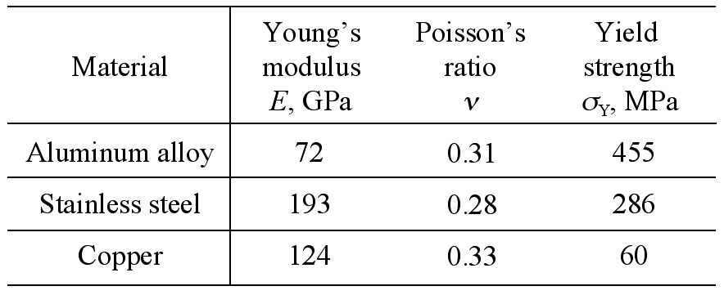

(One line space)
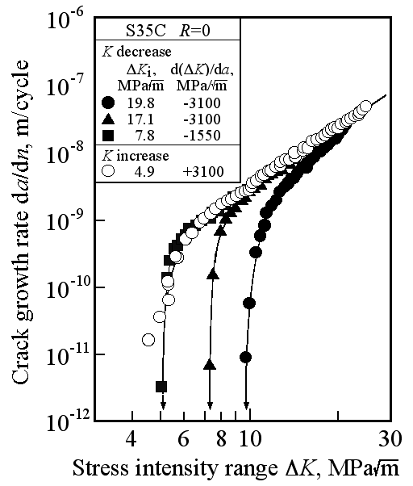

Fig. 1 Relation between da/dn and ΔK.
(One line space)
Main body of text proceeds in such a way. Again please use 9pt Times (New) Roman or equivalent font for the main body.

3 Other Remarks
References, as cited through this example, are numbered in the order in which they are cited in the text with superscript parenthesis such as journals^{1), 2)}, CD-ROM³⁾, books^{4), 5)}, and patents^{6), 7)}. And they all are collected at the end of the text. Full reference should clearly be written in English (even if it is a domestic journal) as shown in the following example. The content of the references should be in 8pt roman.
(One line space)
References
9.5pt Bold (centered)
1) O. Kohda, “Study on metal fatigue”, Journal of the Society of Materials Science, Japan, Vol.54, No.1, pp.123-128 (2005). (8pt roman)
2) G. Sharma, R. V. Ramanujan, T. R. G. Kutty and N. Prabhu, “Indentation creep studies of iron aluminide intermetallic alloy”, Intermetallics, Vol.13, No.1, pp.47-54 (2005).
3) A. Ueno and H. Kishimoto, "Mixed mode crack propagation behavior on glass", Proceedings of the 9th International Conference on the Mechanical Behaviour of Materials, CD-ROM, Geneva, Switzerland (2003).
4) I. Yoshida, “Zairyo-gaku gairon”, pp.83-95 (1978) The Society of Materials Science, Japan .
5) C. Kittel, “Introduction to solid state physics”, pp.56-87 (1976) John Wiley & Sons, New York.
6) T. Zairyo, "Material testing system", JP.2003-012345 (2003).
7) T. Zairyo, "Material testing system", U.S. Pat.No.0, 123, 456 (2004).

Principle of format
1) Name#1, Name#2 and Name#3 (do not use et al.), “Full title of paper”, Journal in full name, Vol.45, No.6 (if number exists), pp. 78(beginning)-90(end) (year in parenthesis) .

